**My Online Shopping Store**

We have a physical shopping store, which is doing well in terms of revenue and margin. We want to increase the business by extending the availability of our products through online mechanisms (website and mobile app).

Quick time-to-market is the main criteria; so we are not looking for fancy and elaborate designs. We rather prefer something which is simple and straightforward. At the same time, it can be extended/modified at a later date to accommodate more features.

To start with we need a basic web-site having

1. Home Page
2. Product Search facility
3. Product Detail Page
4. Add to cart functionality
5. Online payment

Add-to-Cart functionality is optional for one-day hackathon event.

Online payment is out-of-scope for the hackathon event.

Additionally, we are not insisting to provide the registration functionality in the beginning; as a result, login functionality is also not needed.

Functionality to add/edit/delete categories and products, is out-of-scope for current implementation (admin functionality will be a handled separate application).

**Home Page**

Home page of our website shows category wise product listing. Examples from two major web stores are provided as reference.

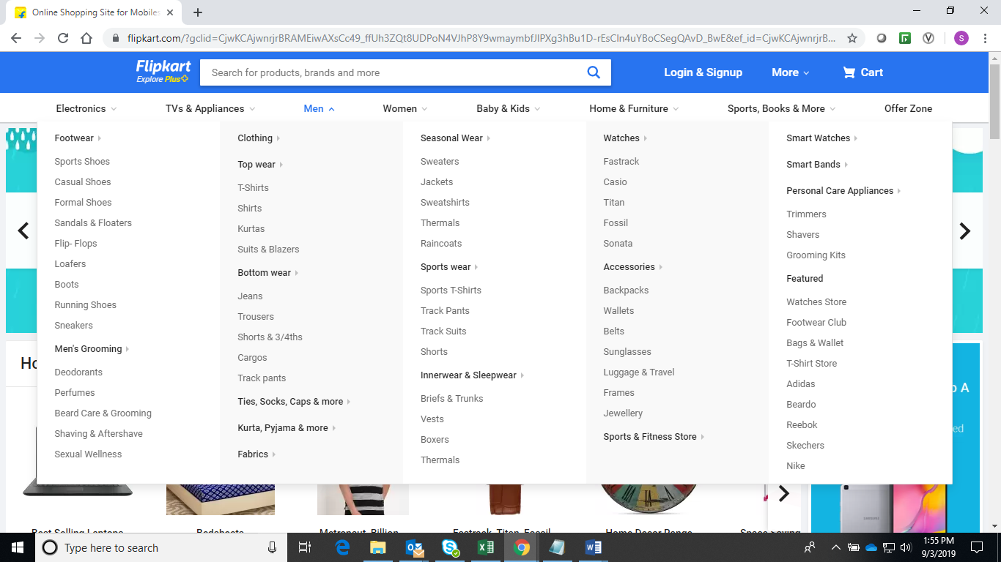

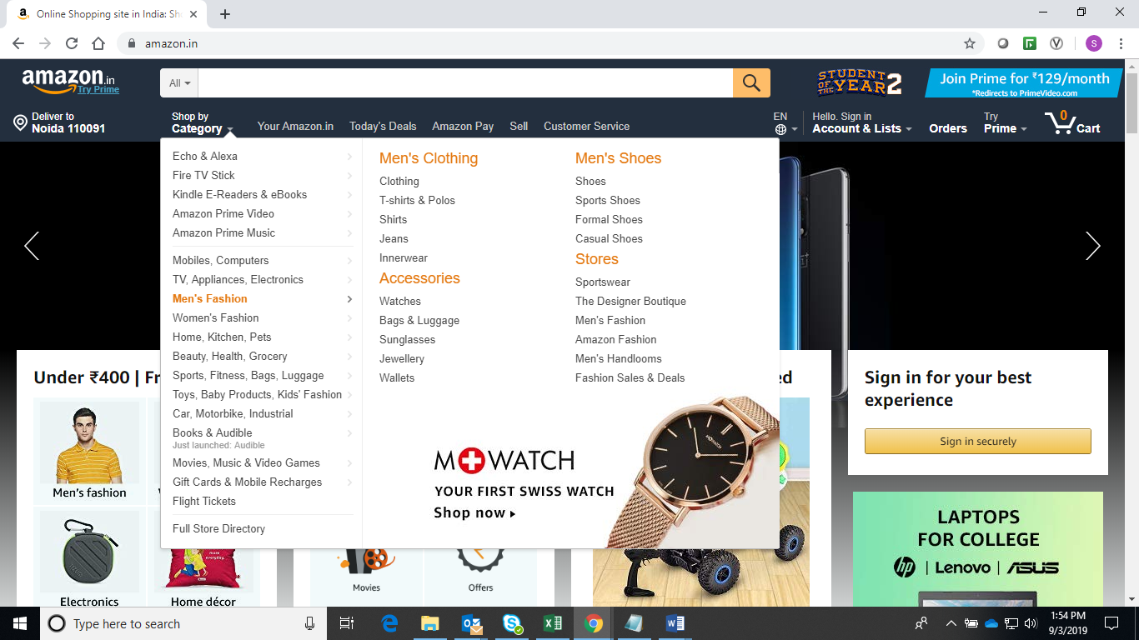

The product categories may be displayed in the top bar or left menu or any other way decided by you as part of site layout it need not replicate any of the above example.

Some generic information about the store, location, contact information may be provided in the empty area of the home page.

**Product Search**

The home page should also provide a search facility, which can be used to look for specific product(s) based on category/sub-category, brand-name or product-name.

Search result should display a list of products which satisfy the search conditions.

It need not be as elaborate as Amazon or Flipkart; and we do not expect you to implement the context sensitive search (normally shown in left panel like price range, brand, user feedback etc.).

The product list on the Search Result page should be a link, leading to the product details page.

Sample pages

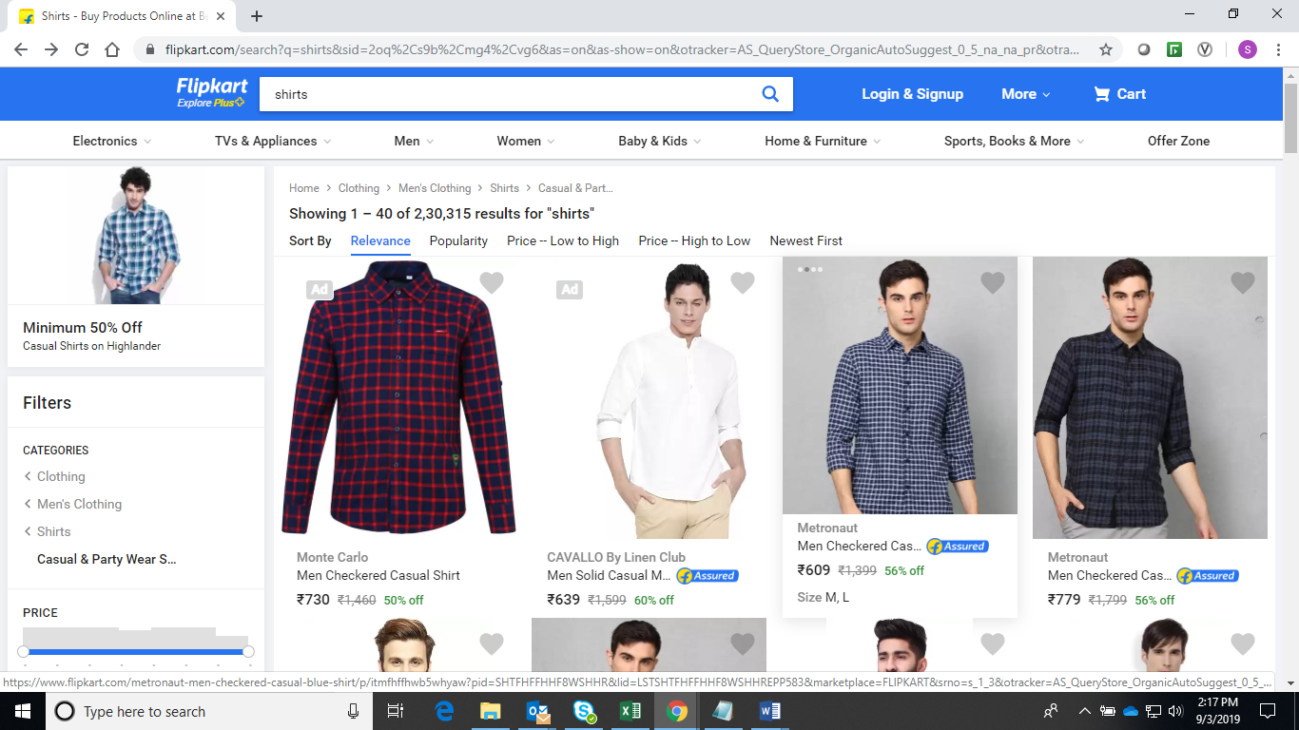

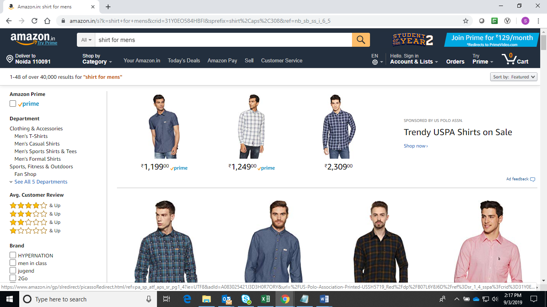

**Product Detail**

This page shows the product specification(s), available sizes, price, discount and other relevant details.

It also provides facility to add the product in shopping-cart (cart implementation is optional for this hackathon exercise).

Sample pages are as follows:

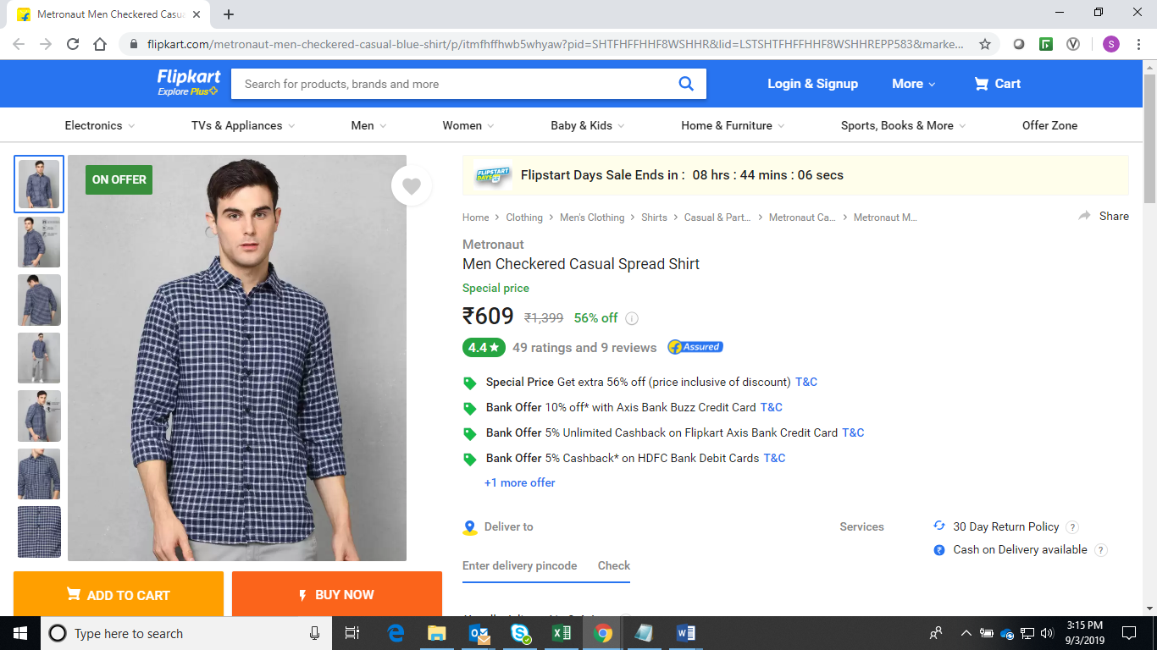

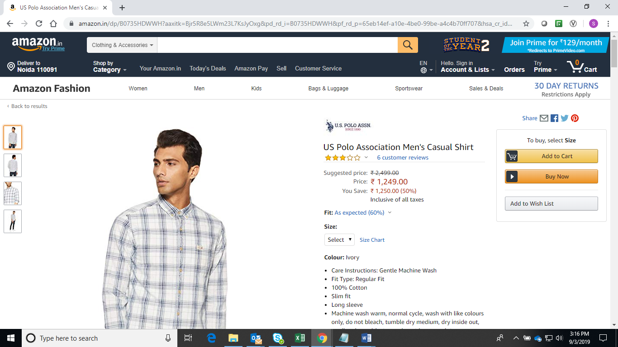

**General Instructions**

1. We do not expect you to develop registration or login functionality.
2. You can refer to Amazon and/or Flipkart to pick 3-5 products categories and products. Do not enter a lot of products or categories; we are looking for a prototype only. However, you are not restricted to use products only from these websites.
3. A simple but working page is preferred over a non-working but good looking page.
4. The product category, product list, product specification and inventory details should come from a data-store and should not be hard-coded. You need to add these details directly in the database (by running queries or by using some tool).
5. Screen-shots provided in this document are only to enable your understanding. We are not expecting same (or similar) implementation for our online web-store.